FOR RENT

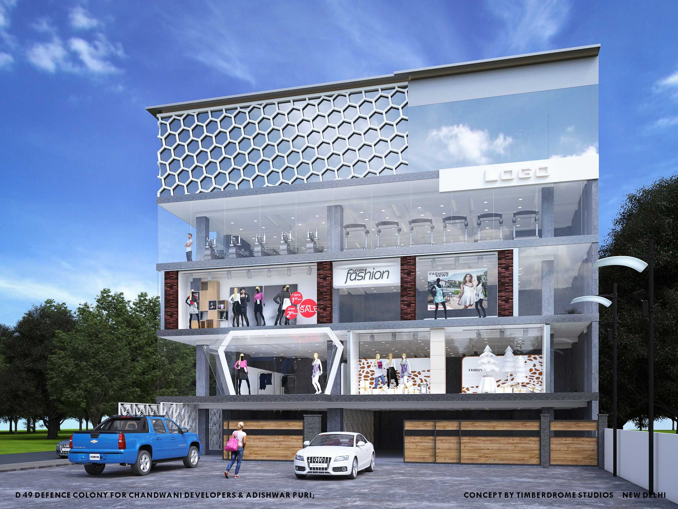

Luxurious corner three side open property with Lobby in the high street market on the main road at D-49, Defence Colony, New Delhi

Super Built up Area | Basement - approx. 2,200 sq. Ft  Ground Floor - approx. 2,200 sq.Ft  1st Floor - approx. 2,200 sq.Ft
Monthly Rental  Sale | For Basement  Rs. 4,00,000/ (Rupeesfour Lakh only)+ GST as applicable  For Ground Floor  Rs.7,00,000/ (RupeesSeven Lakh only)+ GST as applicable  For 1nd Floor  Rs.5,00,000/ (RupeesFive Lakh only)+ GST as applicable  For 1nd Floor  Rs.16,00,00,000 (Rupees sixteen crore only)+ GST as applicable
Lease Period | 9 years (3+3+3 years)
Lock-in-Period | 3 years
RentEscalation | @15% on the Expiry of Every 36 month on Rent, maintenance& security.
Advance Rent | One Month
Security (Interest Free Refundable) | Equal to 6month’s rent (One month security deposit to be paid at the time of signing of LOI and the balance security deposit to be paid at the time of signing/ registration of Lease Deed or handed over possession of property)
Rent free Period | 30 days from the date of Signing of the LOI
Registration/ Stamp Duty Cost | To be borne by tenant.
Rent Commencement Date | On the expiry of Rent free Period
Maintenance | To be paid @ Rs.17.25 per sq. Feet.+ GST
GST | To be paid by Tenant as applicable.
Taxes related to the property | To be borne by the owner.
Signage | As Discussed, the Tenant can have their signage on the area suggested on the floor.
Electricity Meter | Provided.
Power Back –up | Provided.
Lift | 2
Air conditioning | As per Demand.
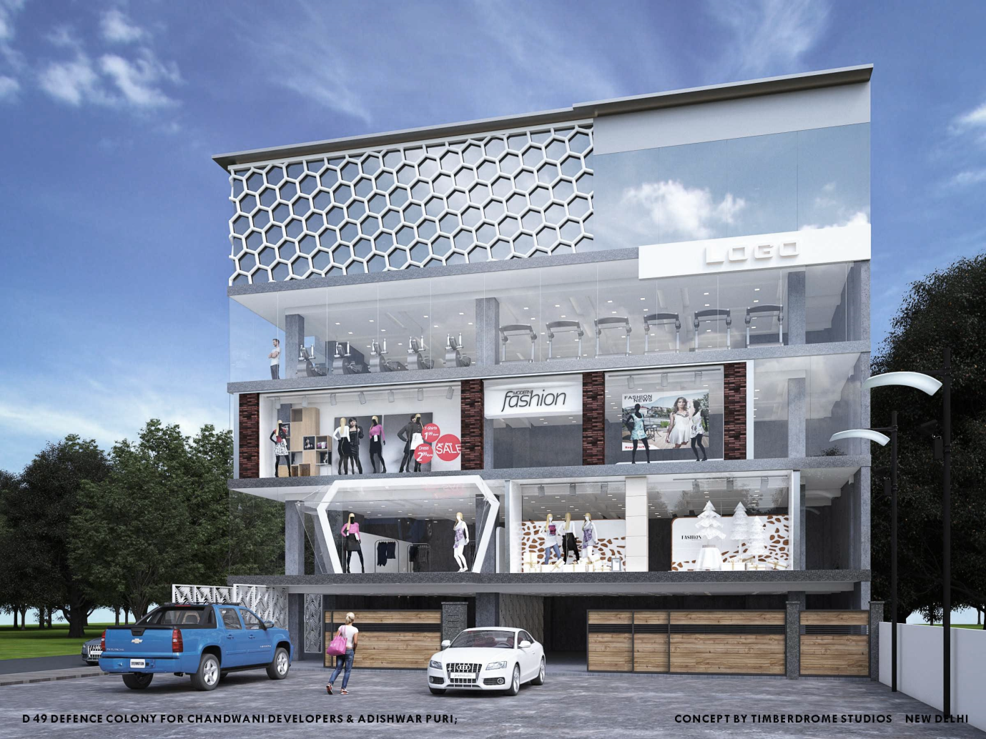For more details, please contact Mr.

